**W3 Implementing the Steps**

**Software**

R Packages

• Free software

• <https://www.r-project.org>

• Over 8,000 packages available

• Packages for this course

- sampling

- survey

- PracTools

Editing code files in R

• Built in editor

• Other options

- R-studio

- WinEdt, use with RWinEdt (R Package)

- Tinn-R

Other software packages

• SAS

• STATA

• SUDAAN

• WesVar

R examples are from the Springer text Practical Tools for Designing and Weighting Survey Samples (2013)

**Base Weights**

Select a sample and compute base weights

• R sampling package will select samples and compute base weights

• Example: select a stratified sample

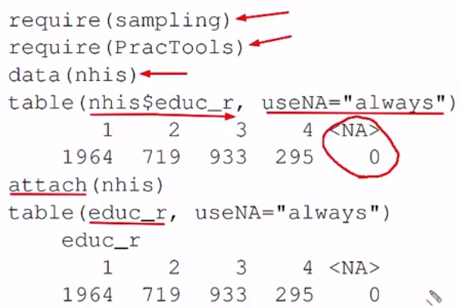

• sampling package will select various kinds of samples and compute base weights

Srswor 🡺 simple random sampling without replacement

Size=rep(3,4) 🡺 4 stratum with 3 sample in each stratum

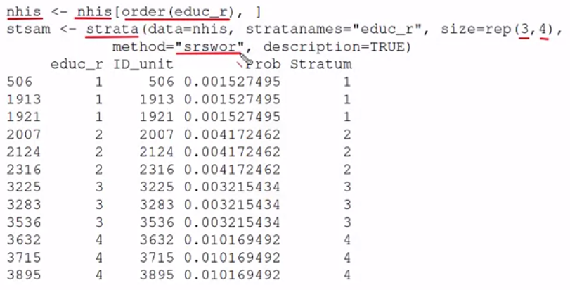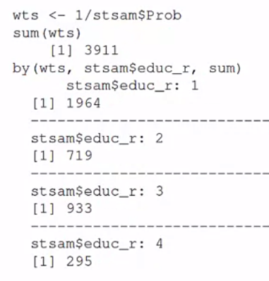

Repeating selection of same sample

• If strata is re-executed, it will use a different random start and select a different set of units

• When any R function that uses random numbers is called, a 626-vector called .Random.seed is formed

• Numbers in position 3:626 can be used a random starts

• Issue a command like this before selecting the sample:

Set.seed(4533223)